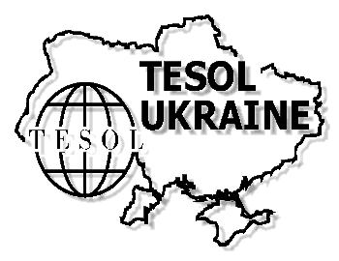 | TESOL-Ukraine  2019 Membership Application
INDIVIDUAL MEMBERSHIP  (leave unfilled if you are a group coordinator) |  | JOINT MEMBERSHIP  (not more than 10 persons)
First Name _______________________ |  | Institution ________________________  _________________________________
Last Name ________________________ |  | Group Coordinator _________________  _________________________________
New Member Renewal
Place of Work __________________________________________________________
Position __________________________________________________________
Years of Teaching __________________________________________________________
Degree / Title
- Bachelor’s Ph.D. Senior Teacher (School) Meritorious Teacher of Ukraine
- Master’s Assoc. Prof. Senior Teacher (University) Full Prof.
Telephone __________________________________________________________
E-Mail __________________________________________________________
Birth Date ____/_____/____
day month year
Special Interest Section (you may choose more than one)
Methods of Teaching English (including CALL – Computer Assisted Language Learning)
English for Specific Purposes (ESP)
English Literature & Culture
Methodology Research
Linguistics Research
Teaching Young Learners

Annual membership rates (e-Newsletter & Forum magazines included) are:
- Individual membership 275 UAH
- Joint membership 1500 UAH (for a group of not more than 10 members)

Payment information:
Громадська організація "Асоціація вчителів англійської мови "ТІСОЛ-УКРАЇНА"
п/р 26008300476660
ТВБВ № 10013/0289 ФЛОУ АТ "ОЩАДБАНК"
МФО (код банку) 325796
Код в ЄДРПОУ 33073458

Date ______________ Signature ________________________
Online forms
TESOL-Ukraine Membership -Individual form
https://goo.gl/forms/5uxbqJtmntW8KmFJ2
(Ctrl+Click)
TESOL-Ukraine Membership – Group form
https://goo.gl/forms/XSqCDsDmJfHkGbyw2
(Ctrl+Click)

Please, fill in the online form and send the scanned membership application (with Appendix for Joint Membership) together with your remittance to both addresses: Oksana Chugai ochugai@meta.ua and Liliya Kuznetsova kuznetsovalily@yahoo.com, and the original papers to your Oblast Leader.

NB: The term of the annual membership is valid for one calendar year. The term of the annual membership payment is fixed: from Jan. 1 to Dec. 31 of the current year (e.g. regular payment for 2019 membership lasts from Jan. 1, 2019 till Dec. 31, 2019). If you pay later your membership is valid only till Dec. 31 of the year of payment.

